43.36: a) 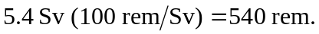 b) The RBE of 1 gives an absorbed dose of 540 rad. c) The absorbed dose is 5.4 Gy, so the total energy absorbed is 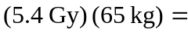
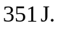 The energy required to raise the temperature of 65 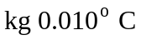 is 